**MODULE 1**: DEPLOYING WORDPRESS WEB APPLICATION BY USING DOCKER IN AMAZON WEB SERVICES

AND

**MODULE 2**: DEPLOYING WORDPRESS WEB APPLICATION BY USING JENKINS IN AMAZON WEB SERVICES

**MODULE 3**: DEPLOYING WORDPRESS WEB APPLICATION BY USING SHELL SCRIPT IN AMAZON WEB SERVICES

BY AJAY

***1.DEPLOYING WORDPRESS WEB APPLICATION BY USING DOCKER IN AMAZON WEB SERVICES***

Process1 :- launching instance

Creat and launch instance (amazon linux ec2)

Go to console and select ec2

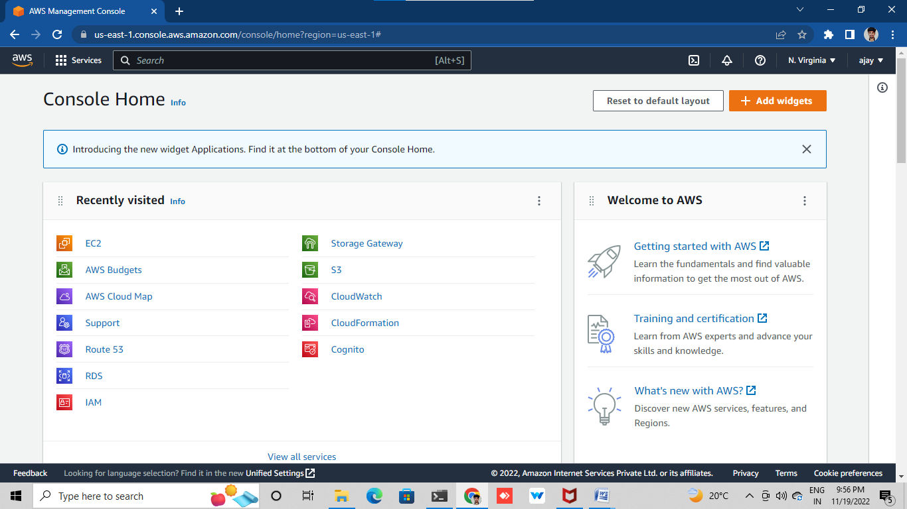

**Choose AMI**

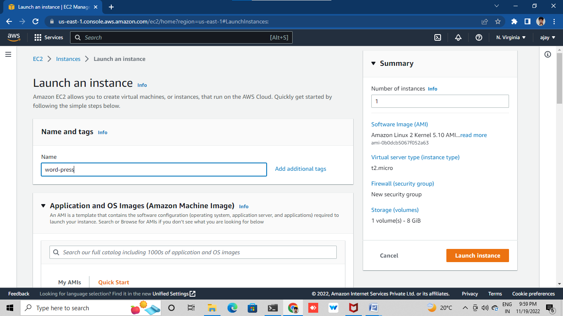

**Choose instance type and also keypair**

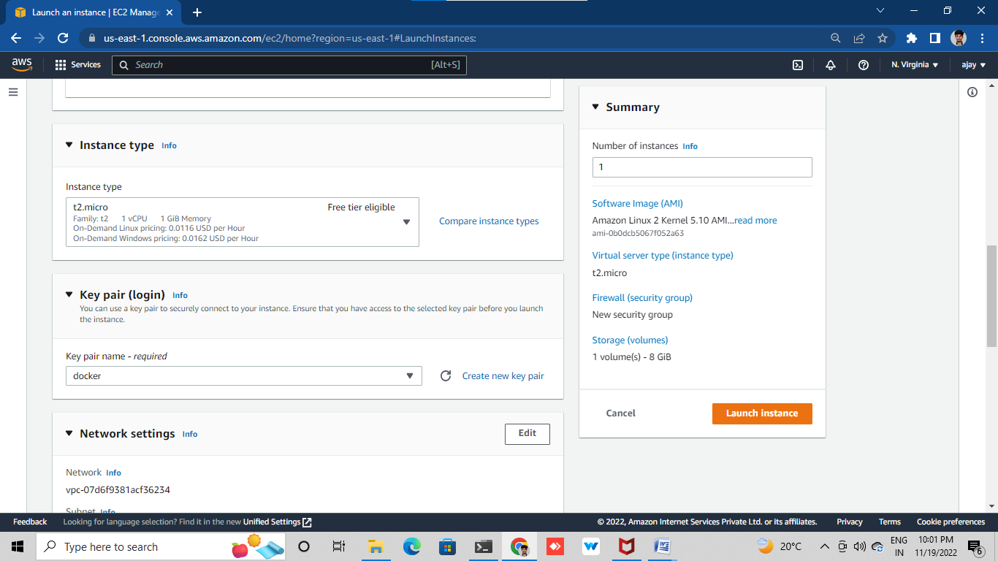

**Select security group (network settings)**

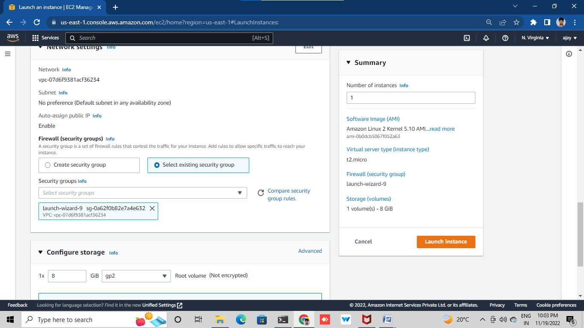

**Add storage and luanche instance**

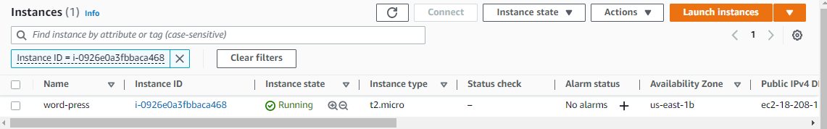

**Connect with ssh client into any one terminal (git bash ,putty)**

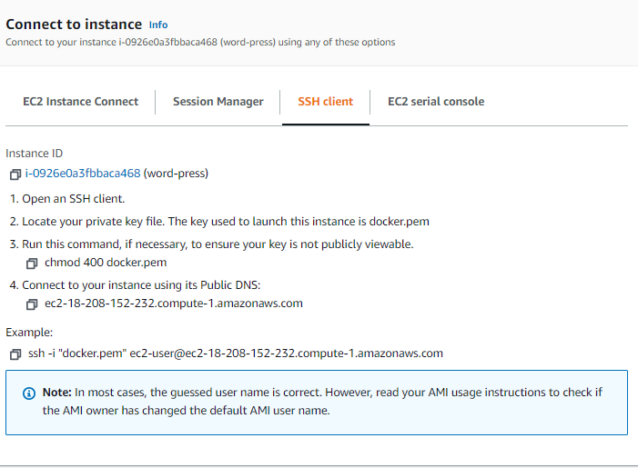

**Connect with terminal and update by using this command**

**Sudo yum update**

**sudo**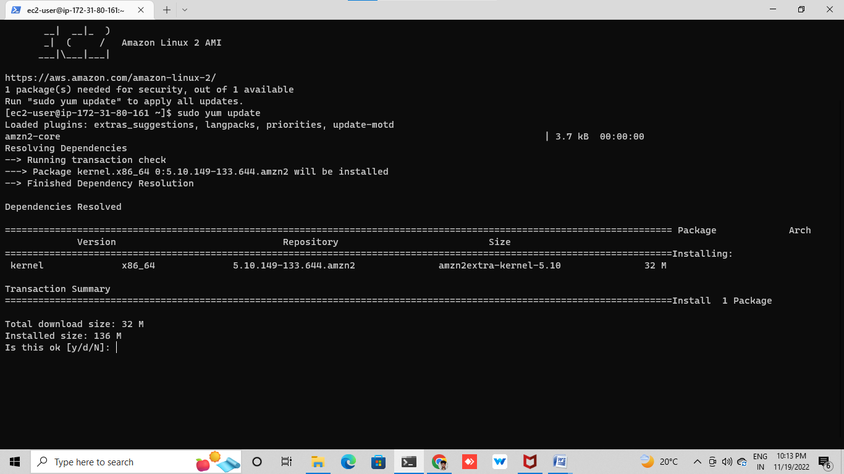

**Process2** :- install git and docker and required repo’s

Install git by using this command

(sudo yum –y install git)

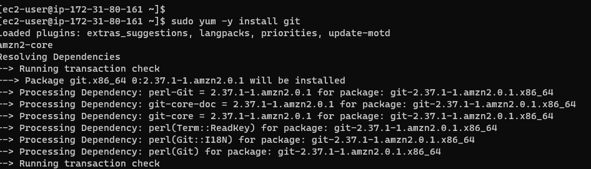

Install docker by using this command

(sudo yum –y install docker)

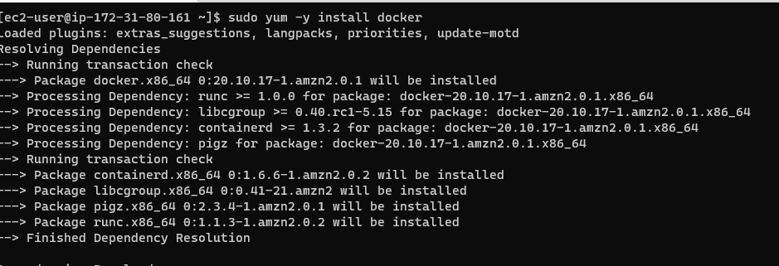

Give a permission for ‘Docker’ group by using command

Sudo usermod –aG docker ec2-user



Start docker and enable it by using this commands

Sudo systemctl start docker



Sudo systemctl enable docker



Install docker –compose file by using this commands

sudo curl -L https://github.com/docker/compose/releases/latest/download/docker-compose-$(uname -s)-$(uname -m) -o /usr/local/bin/docker-compose

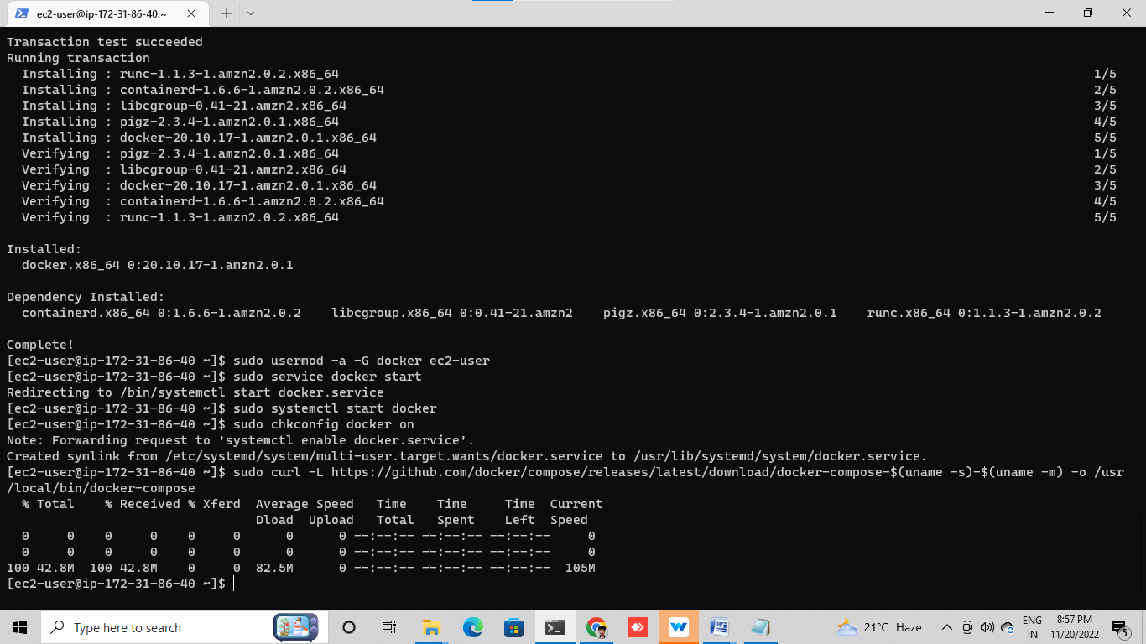

Give executable permissions using

sudo chmod +x /usr/local/bin/docker-compose

Create a symbolic link

sudo ln -s /usr/local/bin/docker-compose /usr/bin/docker-compose



PROCESS :- creating wordpress setup for docker images from whith help of YML scripting

create docker-compose.yaml file to pull images from docker hub

sudo vi docker-compose.yaml

docker-compose. Yaml file (https://gist.github.com/bradtraversy/faa8de544c62eef3f31de406982f1d42)

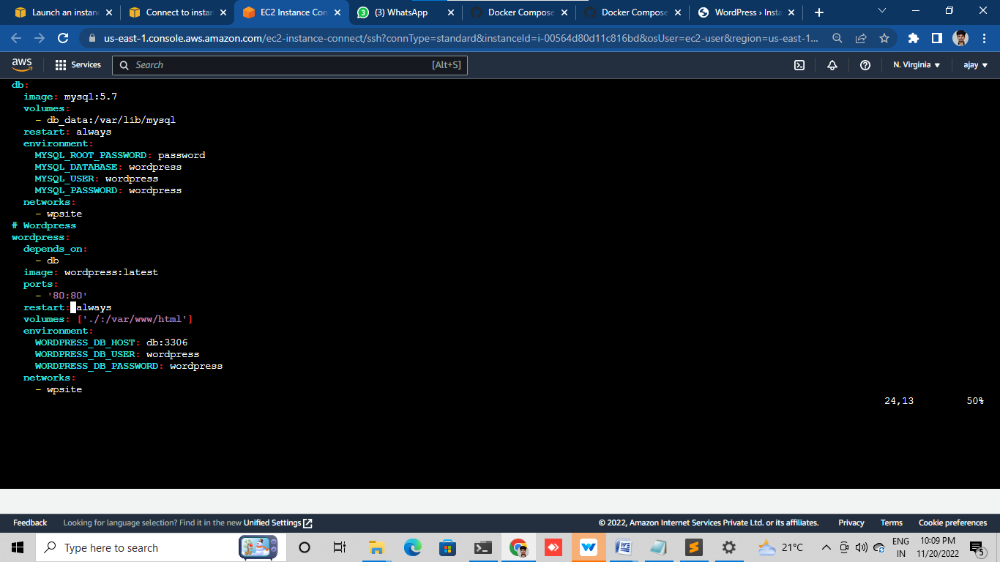

Run thiscommand for puling the images

Sudo docker-compose up –d

By using docker-compose.yaml file it was pulling images are MYSQL and WORDPRESS

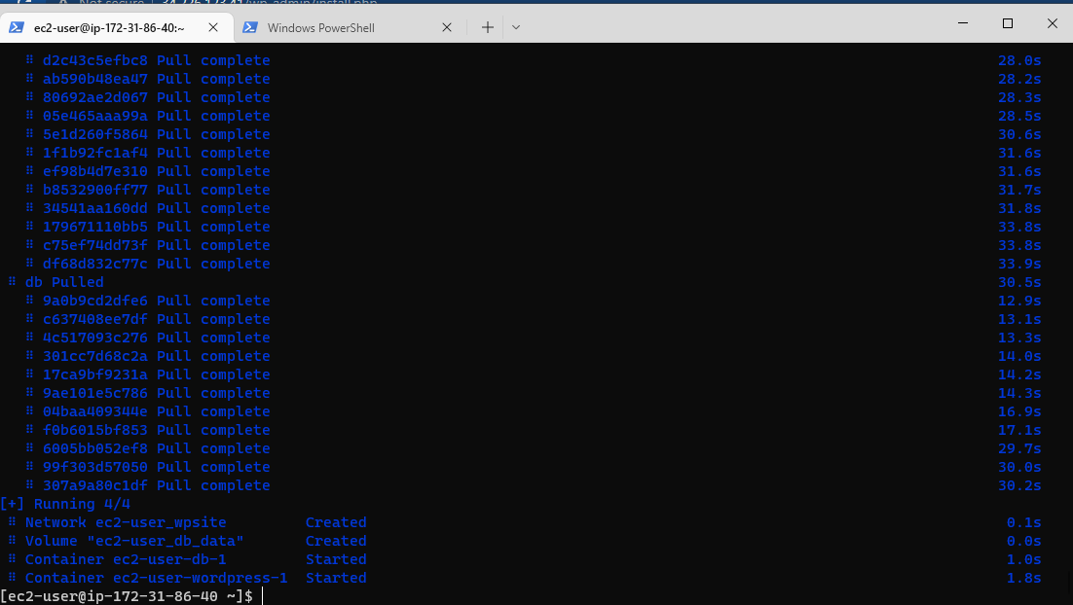

Then I can get the list of running container by using below command

Sudo Docker ps

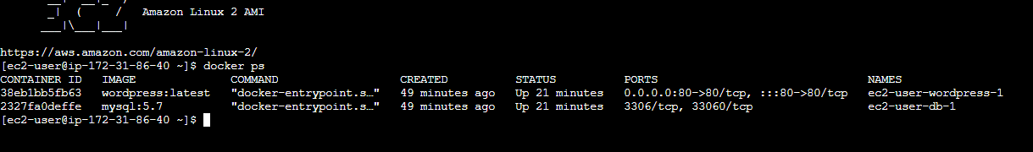

Copy the public IP of instance check the wordpress

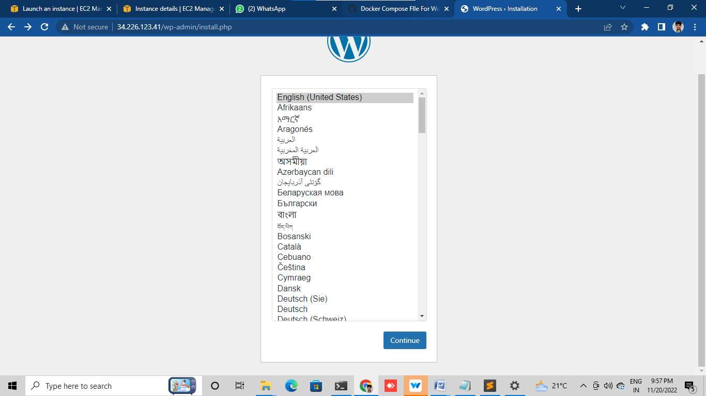

Push the docker-compose.yaml file into git hub

Make a folder

Sudo mkdir <name>

Initialize the folder by using

Sudo git init <folder name>

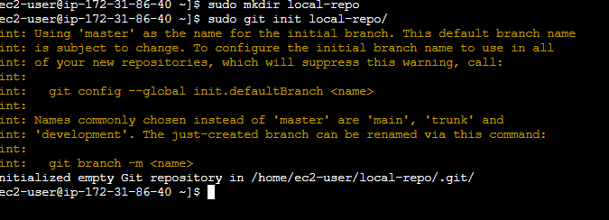

Create remote repo with same name as local repo with out add readme. File

Give connection to remote repo to local repo

git remote add origin <URL of your remote repo>

In terminal, Change name of git branch from master branch to main branch by using command

git branch –M main

push your file local branch to remote repo

sudo git push –-all

It will ask user name and password

check it in github

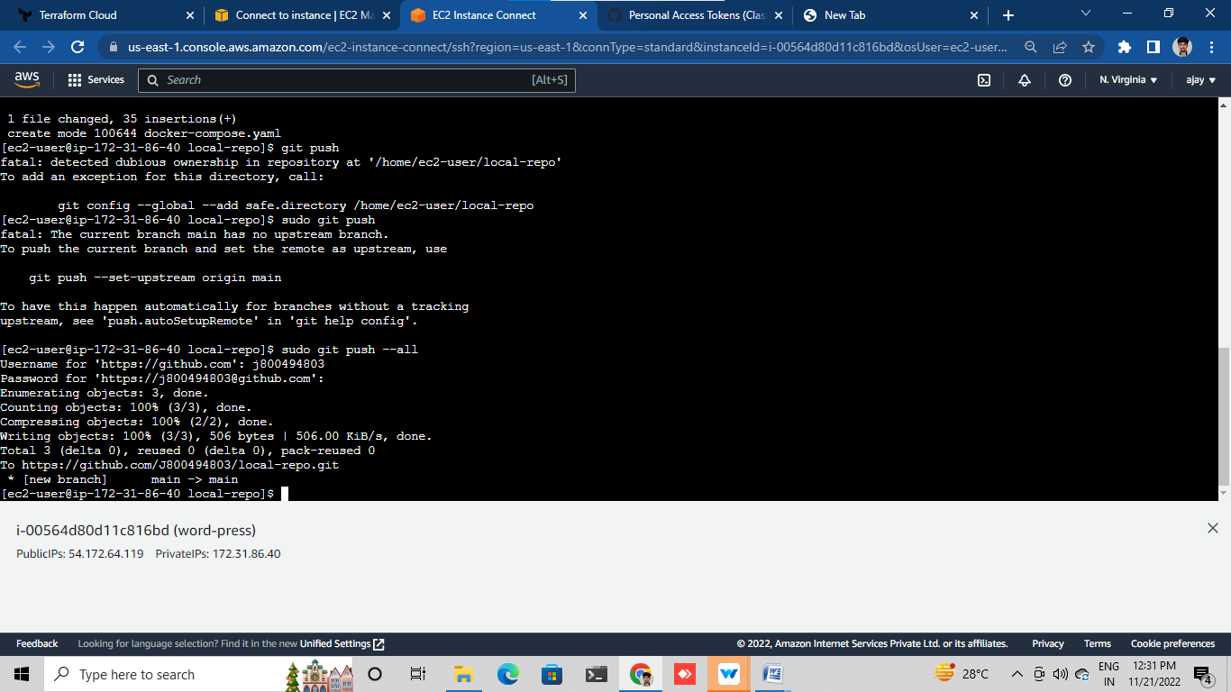

Check in your git hub

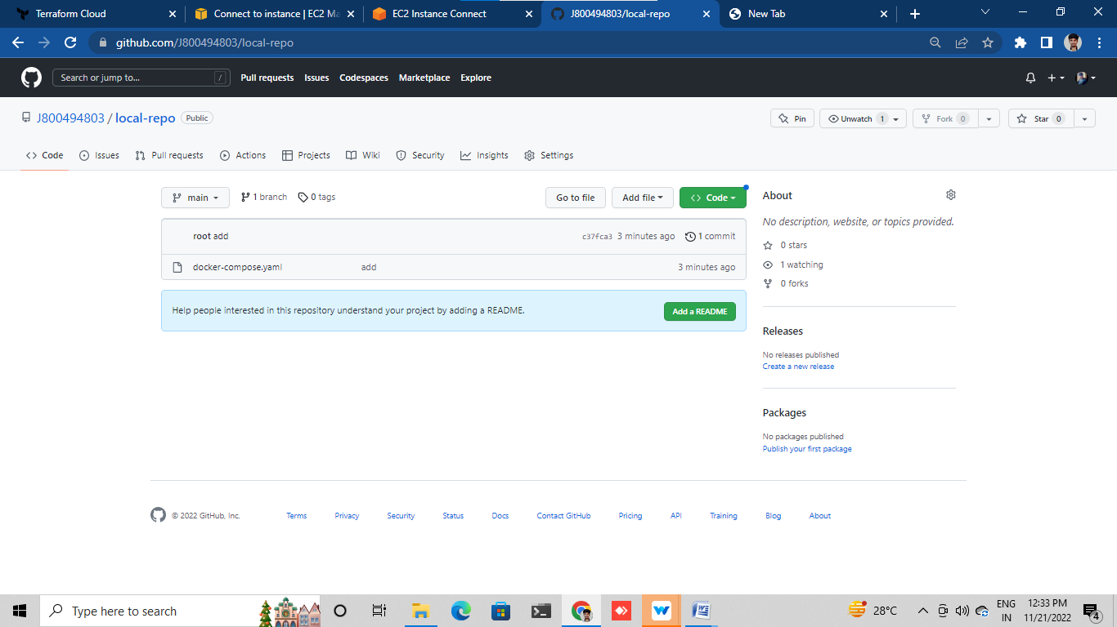

2. DEPLOYING WORDPRESS WEB APLLICATION USING JENKINS IN AMAZON WEB SERVICES

Launch EC2 instance with Amazon Linux 2 AMI and required security group for JENKINS (8080)

Connect SSH client into terminal

Update the system

Install Git in instance using

Sudo yum –y install git

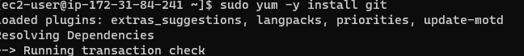

Install the java 11 version for the JENKINS

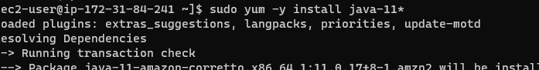

Install Jenkins by using this commands

sudo wget -O /etc/yum.repos.d/jenkins.repo <https://pkg.jenkins.io/redhat-stable/jenkins.repo>

sudo rpm --import <https://pkg.jenkins.io/redhat-stable/jenkins.io.key>

sudo yum –y install jenkins

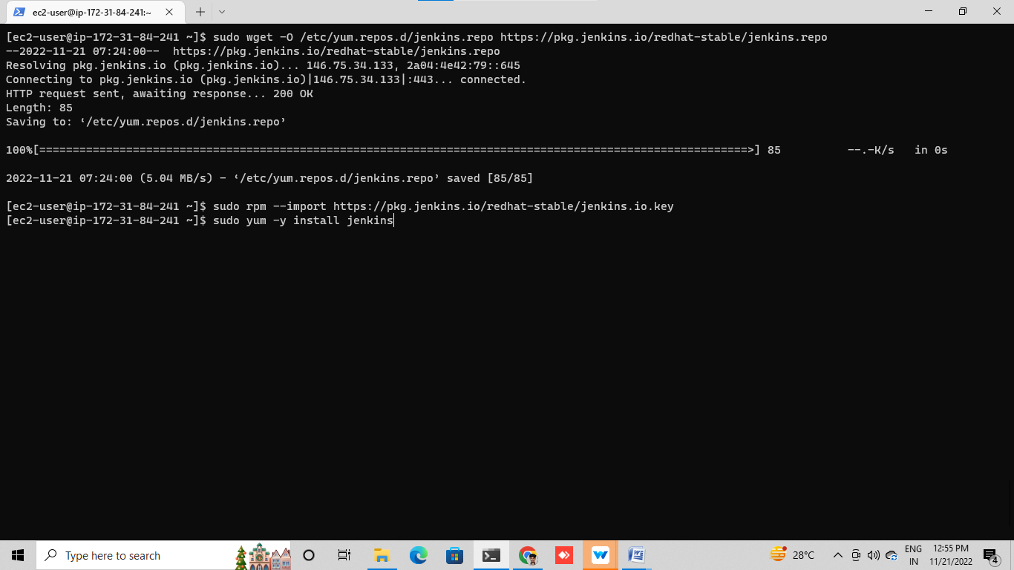

Sudo yum –y install Jenkins

Sudo yum –y enable jenkins



Search on tab with instance public ip with (8080)

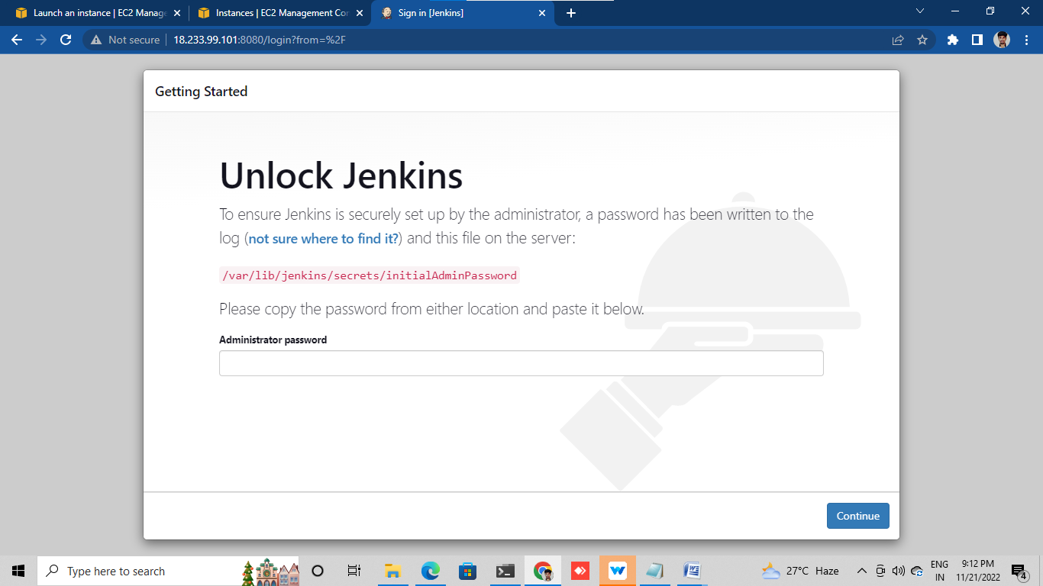

Unlock Jenkins with password for use this command

sudo cat /var/lib/jenkins/secrets/initialAdminPassword

then it will show tha password copy and paste unlock Jenkins



Select installed plugins

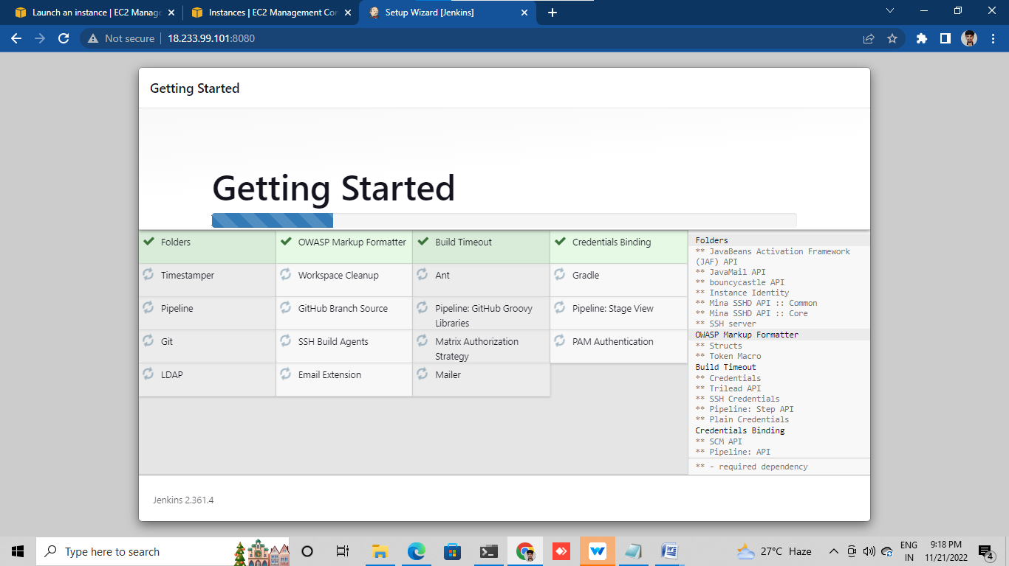

Create a new job

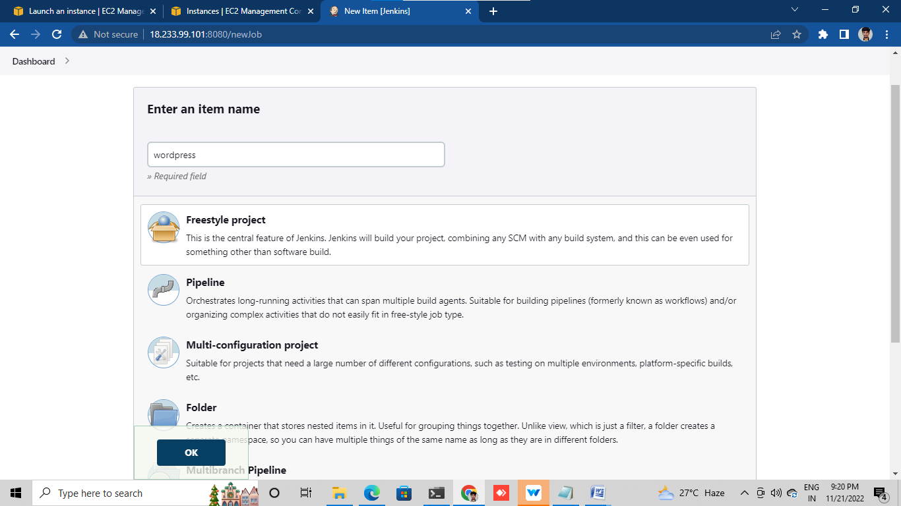

In job, clone the code of docker-compose.yml from git hub

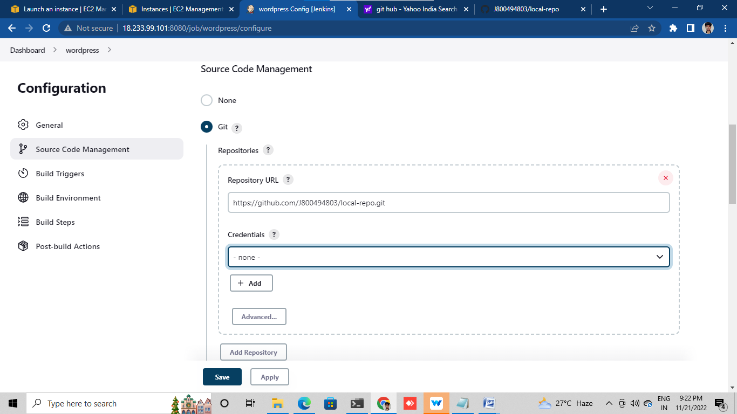

Save it and build now

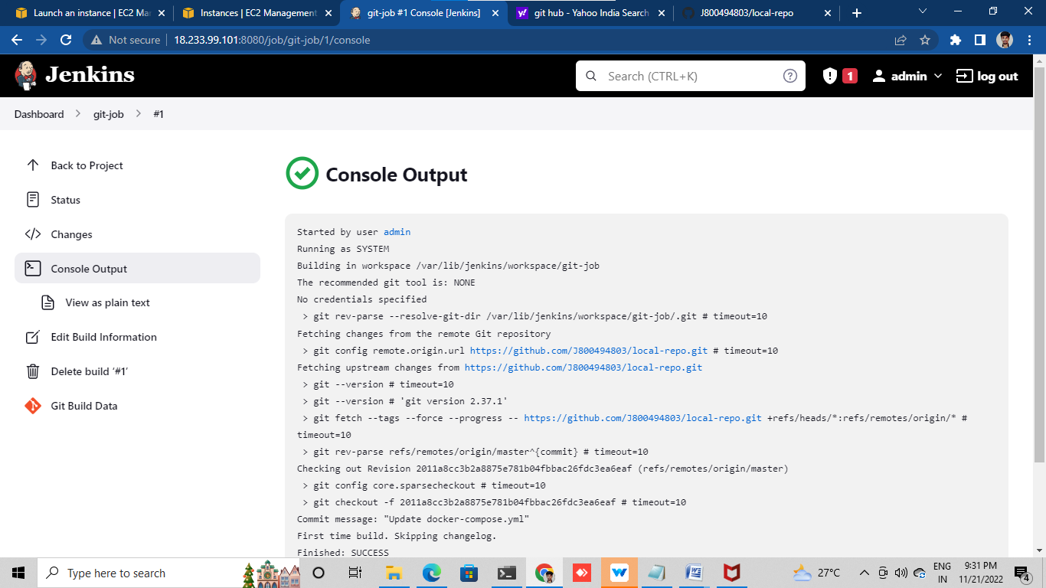

Install docker in instance using

Sudo yum –y install docker

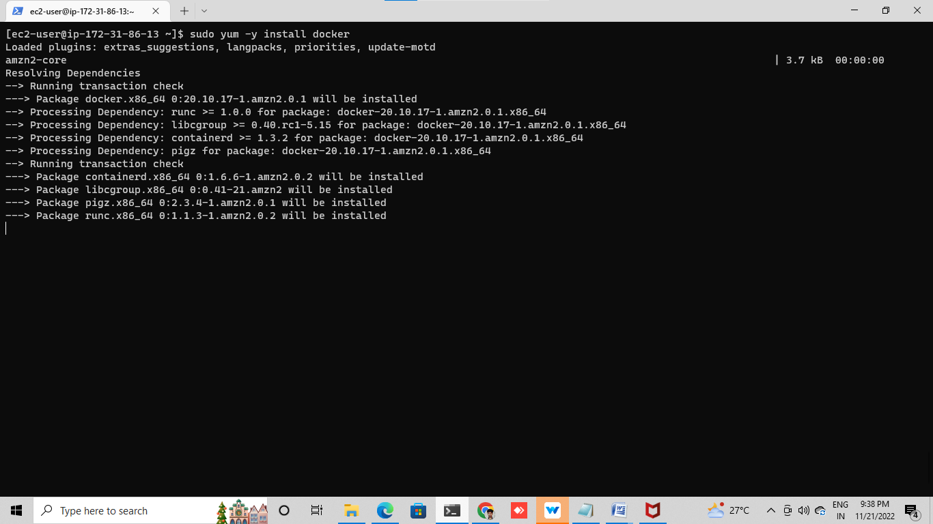

Give permission for ‘Docker ‘ group using

Sudo usermod -a -G docker ec2-user



Start the docker service and enable docker service using

Sudo service docker start (or) sudo systemctl start docker

Sudo chkconfig docker on (or)sudo systemctl enable docker



Install docker-compose using

sudo curl -L https://github.com/docker/compose/releases/latest/download/docker-compose-$(uname -s)-$(uname -m) -o /usr/local/bin/docker-compose

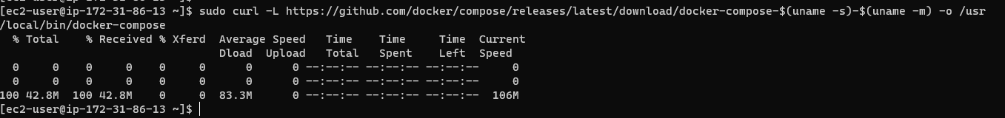

Give executable permissions using

Sudo chmod +x /usr/local/bin/docker-compose

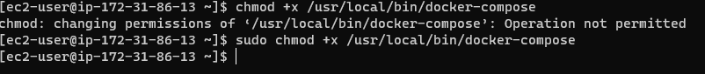

Create a symbolic link

ln -s /usr/local/bin/docker-compose /usr/bin/docker-compose

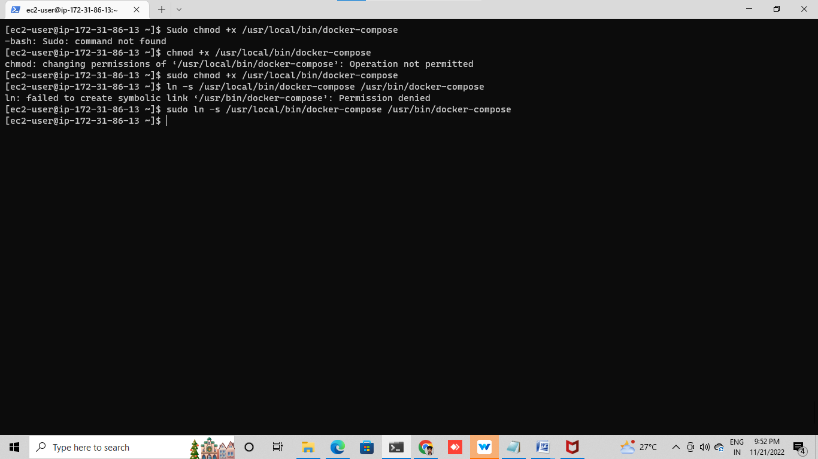

Give permisition docker and Jenkins by using this command

Sudo visudo

Edit like

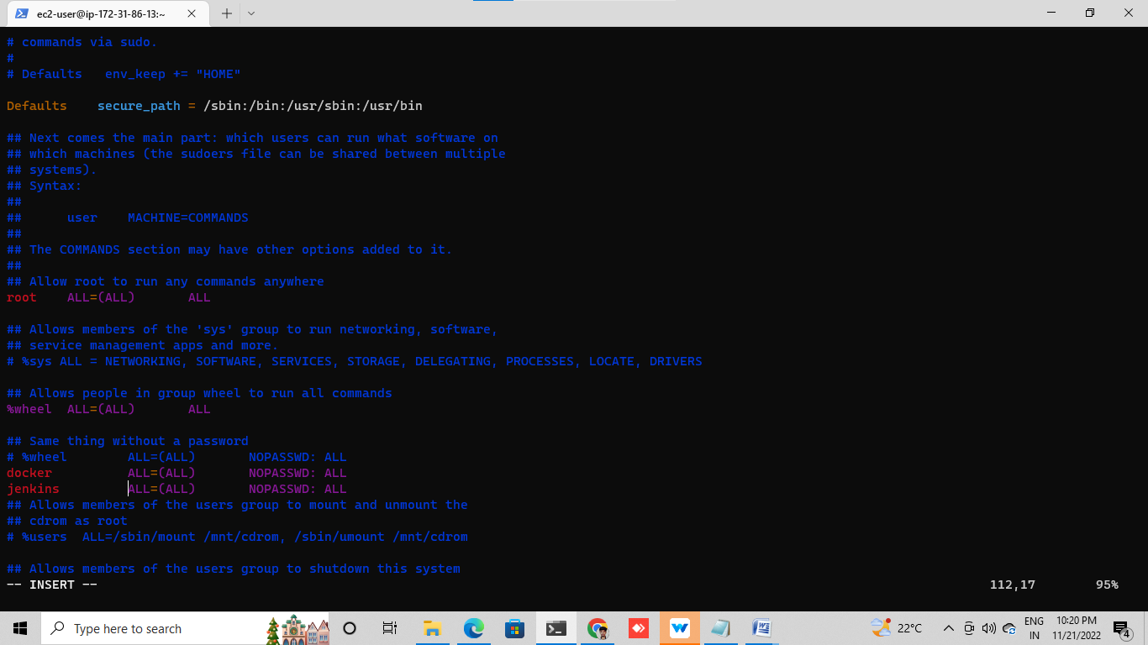

Then , create another job select copy from previous job

In build section select Execute shell

In Excute shell give command for pulling the images from docker hub

Sudo docker-compose up –d

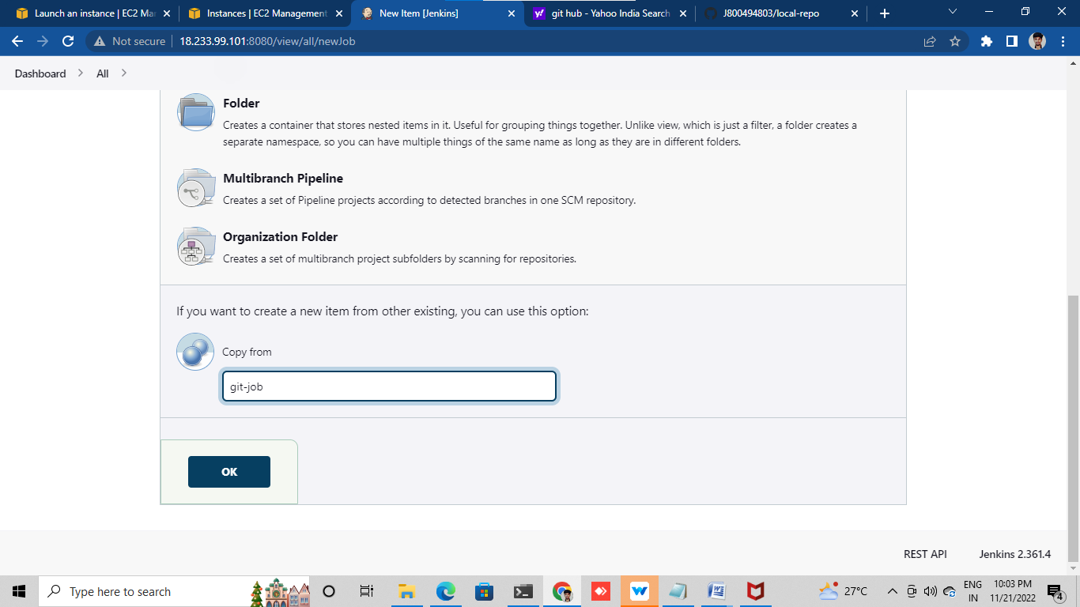

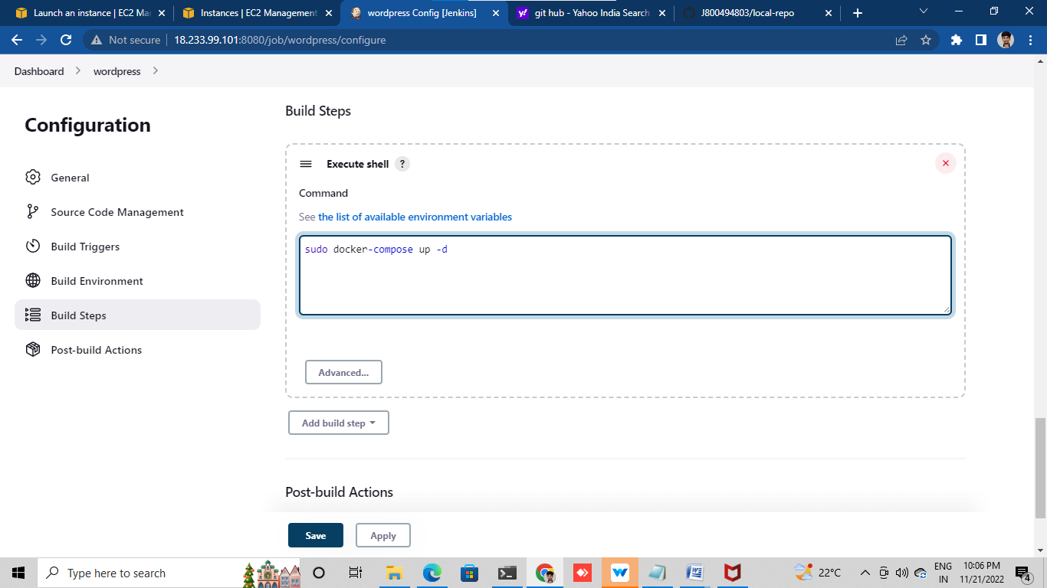

Save it and build now

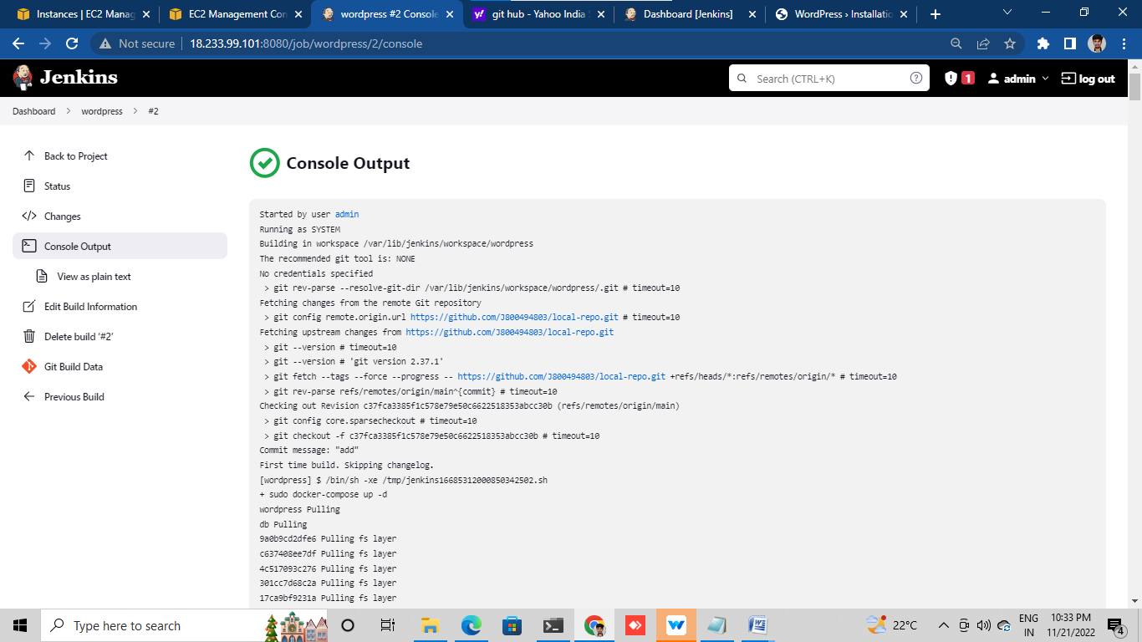

check the docker container using

Sudo Docker ps



public IP of instance and check word press running or not

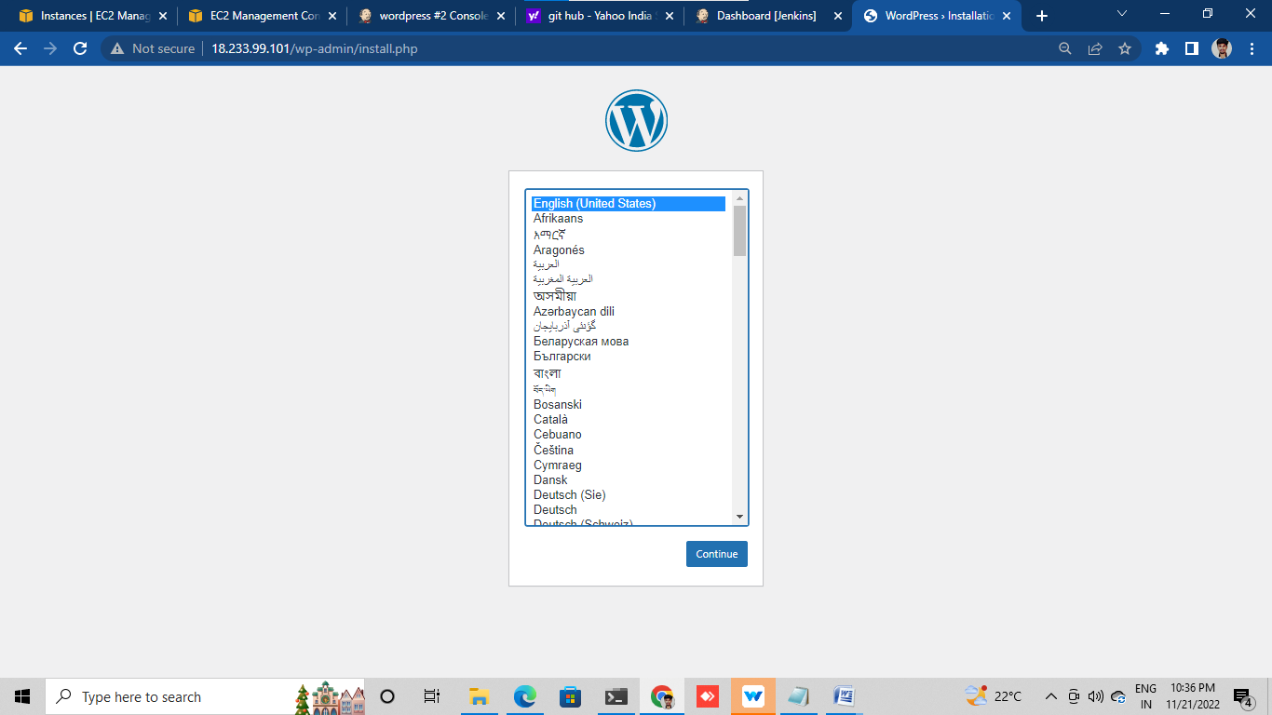

3. DEPLOYING WORDPRESS WEB APLLICATION USING SHELL SCRIPTING IN AMAZON WEB SERVICES

Luanch one instance

What instance ask requires just fille

Last selet additional and go to last

Select tha user data and file like shell scripting

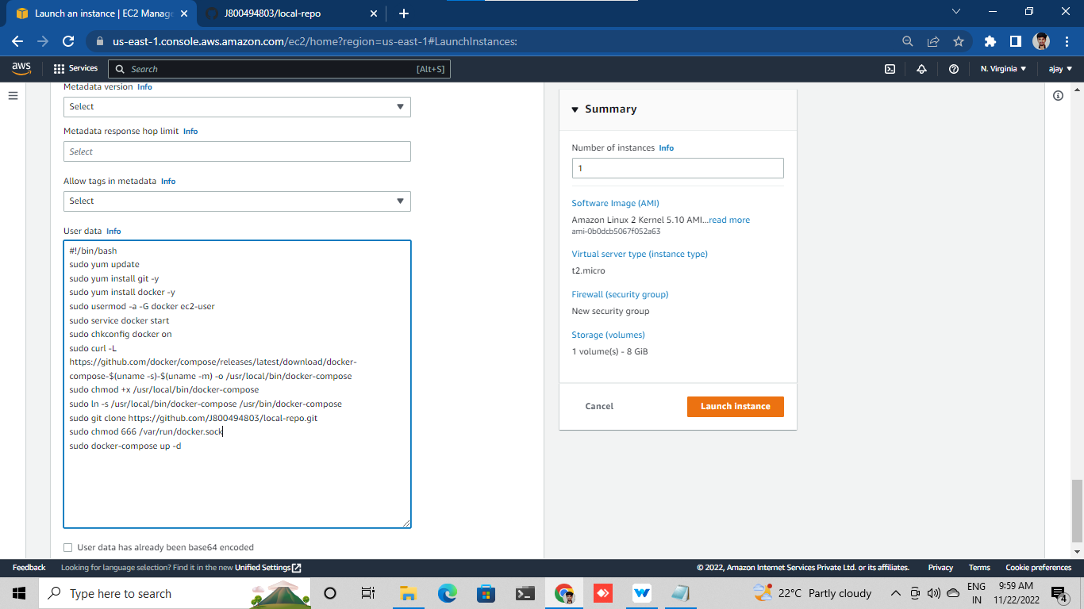

Then ofter searchon tab by using instance public ip+80

